Analysis of Walshing Residuals in the RFCBs
Introduction
In order to prevent cross-talk within the signal processing system of the ATA, Walsh functions are applied to the incoming data from the antennas after the signal is received via fiber and mixed in the RFCB. Walsh functions are a set of square waves that alternate between 1 and -1 (0 to 180 in phase) with frequencies that are all powers of 2 from the lowest frequency, i.e. 200 Hz, 400 Hz, 800 Hz, ect. After the signal passes through the region that is prone to cross-talk, the Walsh functions are removed. Any cross-talk that contaminated the signal remains phase modulated after this removal so when it is integrated, the contaminating signal averages to 0. Within the RFCB the Walsh function is generated using an analogue system but is later removed with a digital system. Because the analogue system is not perfect, the generated Walsh functions is not necessarily being perfectly switched between 0 and 180 degree phases. This imperfection in the Walshing leaves residual Walshing within the signal that can contaminate the data. In this analysis we seek to measure the residuals for the different RFCBs for each antenna and examine possible solutions.
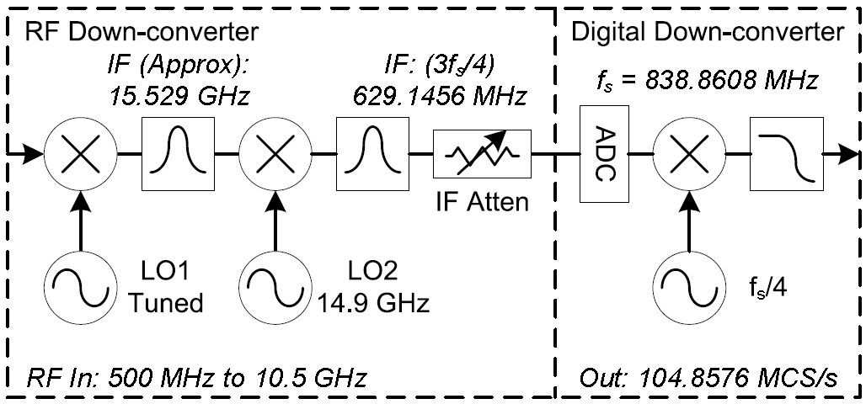
Observations of Residuals:
On 3 March and 20 June 2010 the each antenna of the ATA observed a GPS Satellite and collected data for 10 seconds. The data was then stripped of the GPS encoding leaving the very stable GPS carrier, which was then analyzed for the Walsh residuals. The residuals were measured by a simple folding algorithm that folded the data at a period equal to the Walsh function and then calculated the resulting angle for each complex sample. The deviation of these samples from zero was then measured.
3 March Data:
 | X Polarization |  | Y Polarization |  |  | X Polarization |  | Y Polarization
Antenna | Walsh Freq(Hz) | Residual  (Degree) | Walsh  Freq(Hz) | Residual  (Degree) | Antenna | Walsh Freq(Hz) | Residual  (Degree) | Walsh  Freq(Hz) | Residual  (Degree)
1a | 200 | 10.56 | 100 | 5.605 | 3e | 3200 | 1.007 | 1600 | 6.622
1c | 3200 | 6.617 | 1600 | 6.972 | 3f | 12800 | 1.356 | 6400 | 2.125
1d | 12800 | 8.269 | 6400 | 8.141 | 3g | 200 | 2.314 | 100 | 2.875
1e | 200 | 8.89 | 100 | 7.932 | 3j | 3200 | 1.392 | 1600 | 1.239
1f | 800 | 10.91 | 400 | 9.396 | 3l | 12800 | 56.57 | 6400 | 41.55
1g | 3200 | 1.418 | 1600 | 1.599 | 4f | 800 | 2.644 | 400 | 3.123
1h | 12800 | 2.618 | 6400 | 0.5848 | 4g | 3200 | 4.195 | 1600 | 2.7
1k | 800 | 1.992 | 400 | 3.514 | 4h | 12800 | 5.858 | 6400 | 1.887
2a | 3200 | 5.625 | 1600 | 4.226 | 4j | 200 | 2.722 | 100 | 4.589
2c | 200 | 2.356 | 100 | 2.817 | 4k | 800 | 1.783 | 400 | 1.941
2f | 12800 | 7.117 | 6400 | 4.207 | 4l | 3200 | 2.501 | 1600 | 0.9552
2g | 200 | 3.822 | 100 | 5.517 | 5b | 12800 | 6.37 | 6400 | 1.769
2j | 3200 | 2.144 | 1600 | 0.7344 | 5e | 200 | 5.007 | 100 | 7.757
2k | 12800 | 2.048 | 6400 | 4.026 | 5g | 800 | 3.301 | 400 | 4.175
2l | 200 | 21.91 | 100 | 3.321 | 5h | 800 | 7.422 | 400 | 2.823
3d | 800 | 10.55 | 400 | 15.04

20 June Data:
 | X Polarization |  | Y Polarization |  |  | X Polarization |  | Y Polarization
Antenna | Walsh Freq(Hz) | Residual  (Degree) | Walsh  Freq(Hz) | Residual  (Degree) | Antenna | Walsh Freq(Hz) | Residual  (Degree) | Walsh  Freq(Hz) | Residual  (Degree)
1a | 200 | 7.20 | 100 | 4.24 | 3f | 12800 | 1.29 | 6400 | 2.18
1c | 3200 | 5.25 | 1600 | 0.87 | 3g | 200 | 1.76 | 100 | 2.29
1d | 12800 | 4.72 | 6400 | 5.01 | 3h | 800 | 2.85 | 400 | 1.98
1g | 3200 | 4.82 | 1600 | 0.93 | 3j | 3200 | 1.51 | 1600 | 1.35
1h | 12800 | 1.87 | 6400 | 1.29 | 3l | 12800 | 56.96 | 6400 | 41.27
2a | 3200 | 6.23 | 1600 | 4.65 | 4e | 200 | 1.81 | 100 | 2.21
2b | 12800 | 1.00 | 6400 | 2.28 | 4f | 800 | 2.51 | 400 | 2.44
2c | 200 | 2.25 | 100 | 3.41 | 4g | 3200 | 4.17 | 1600 | 2.50
2e | 3200 | 13.18 | 1600 | 13.17 | 4h | 12800 | 6.59 | 6400 | 2.29
2f | 12800 | 14.06 | 6400 | 7.79 | 4j | 200 | 2.38 | 100 | 4.34
2g | 200 | 2.59 | 100 | 3.69 | 4k | 800 | 1.67 | 400 | 1.87
2j | 3200 | 2.20 | 1600 | 2.37 | 5b | 12800 | 7.55 | 6400 | 2.15
2k | 12800 | 2.25 | 6400 | 4.01 | 5c | 200 | 3.91 | 100 | 4.06
2m | 800 | 1.17 | 400 | 14.81 | 5e | 200 | 2.12 | 100 | 2.21
3d | 800 | 1.43 | 400 | 1.75 | 5g | 800 | 4.03 | 400 | 4.79
3e | 3200 | 0.81 | 1600 | 6.90

From this data we can observe that there is significant variation within the residuals for the different antennas . The data was also analyzed to compare the residuals for the two polarizations for the same antenna and also to look at the variation of the residuals between the two data collections:
 | Difference in the residual of the X and Y Polarization (i.e. X-Y) |  | Difference in the residuals of the same polarization over time (i.e. X2-X1)
Antenna | 1st Observation | 2nd Observation | X Polarization | Y Polarization
1a | 4.955 | 2.956 | -3.36 | -1.361
1c | -0.355 | 4.3847 | -1.363 | -6.1027
1d | 0.128 | -0.286 | -3.548 | -3.134
1g | -0.181 | 3.8901 | 3.401 | -0.6701
1h | 2.0332 | 0.58 | -0.745 | 0.7082
2a | 1.399 | 1.579 | 0.608 | 0.428
2c | -0.461 | -1.154 | -0.105 | 0.588
2f | 2.91 | 6.272 | 6.943 | 3.581
2g | -1.695 | -1.091 | -1.228 | -1.832
2j | 1.4096 | -0.165 | 0.058 | 1.6326
2k | -1.978 | -1.757 | 0.203 | -0.018
3d | -4.49 | -0.319 | -9.119 | -13.29
3e | -5.615 | -6.0884 | -0.1944 | 0.279
3f | -0.769 | -0.89 | -0.067 | 0.054
3g | -0.561 | -0.529 | -0.551 | -0.583
3j | 0.153 | 0.159 | 0.115 | 0.109
3l | 15.02 | 15.69 | 0.39 | -0.28
4f | -0.479 | 0.075 | -0.132 | -0.686
4g | 1.495 | 1.673 | -0.023 | -0.201
4h | 3.971 | 4.305 | 0.733 | 0.399
4j | -1.867 | -1.956 | -0.339 | -0.25
4k | -0.158 | -0.198 | -0.115 | -0.075
5b | 4.601 | 5.395 | 1.175 | 0.381
5e | -2.75 | -0.085 | -2.884 | -5.549
5g | -0.874 | -0.762 | 0.728 | 0.616

It appears that the residuals of the most of the antennas are stable between the two data collection, but there is still a significant minority which see changes. Also there appears to be little correlation between the X and Y polarizations of the two antennas. These results are summarized by the following histograms, note that antenna 3l is removed from them because of an error that is different from the Walsh residuals.
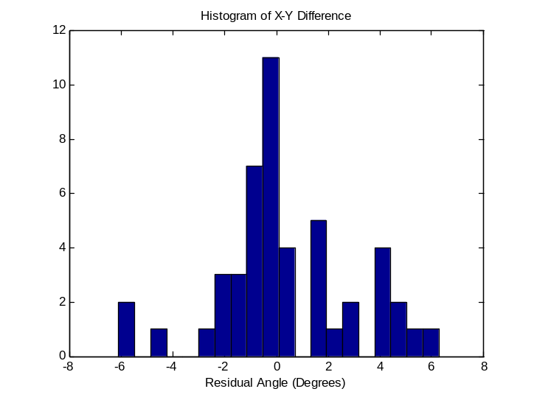
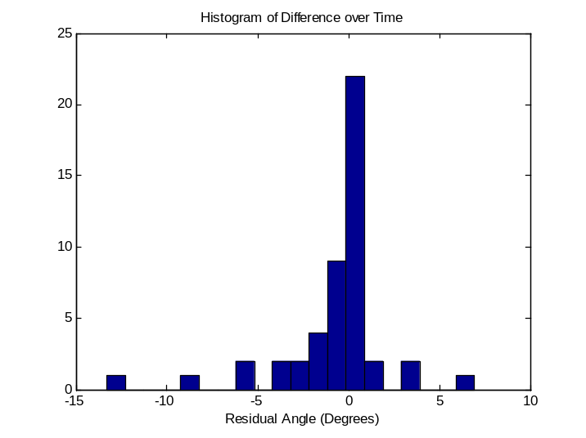

3L:
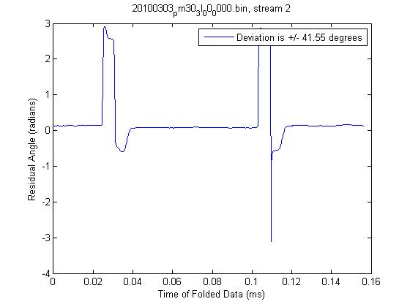
When the folded phase plot for 3L was analyzed a significant anomaly was found at a frequency of twice the Walsh function or 25.6 KHz that can be seen in the plot bellow. The system was troubleshot using a series of GPS observations and switching the output of the RFCB to an iBob that was known to work. This trouble shooting revealed that the problem did in fact lie in the RFCB so the RFCB for 3L was switched with an extra. The new washing characteristics can be seen in bellow.

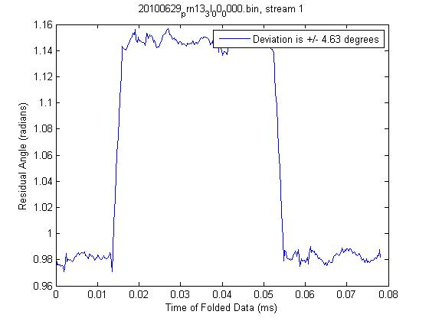

Lab Measurements:
Because the Walsh functions are applied when the signal is mixed with LO2, we varied the input power levels for the LO to three different RFCBs and used another signal generator to feed the Walsh function generator with a set Walsh function. We then took the output signal and fed it into a spectrum analyzer to compare the power of the carrier to the power of the first sideband. If the Walsh functions were perfectly switching from 0 to 180, we would expect perfect carrier suppression.
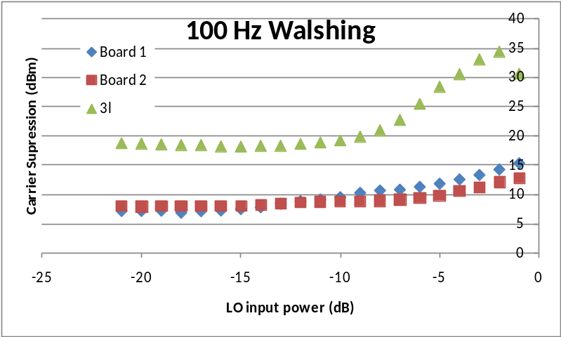
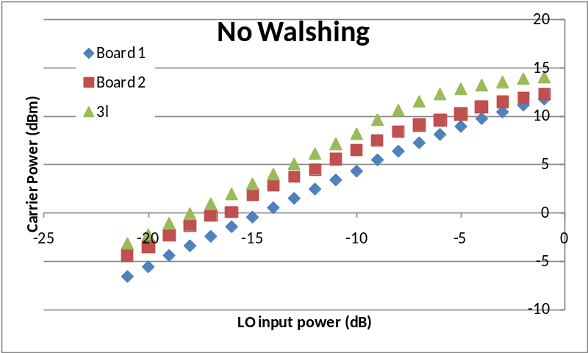

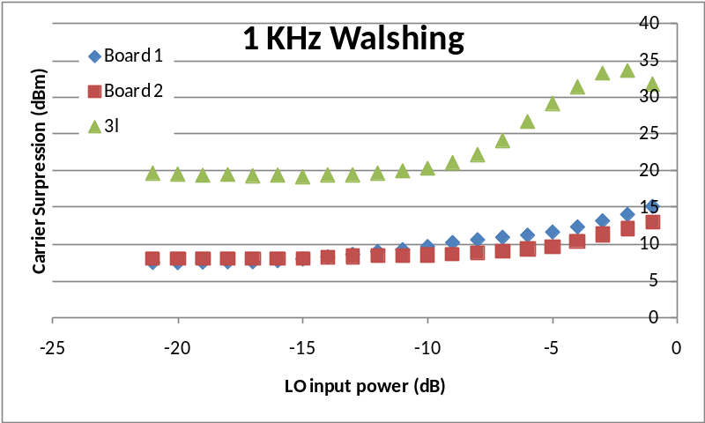

With these three graphs we can analyze both the general characteristics and the deviation from the general character of the 3L RFCB. It appears that the anomaly in 3L occurs only when the Walshing is applied which is not surprising. For further analysis of 3L see the set of graphs bellow. We see in general though that as LO power increases suppression increases nonlinearly.

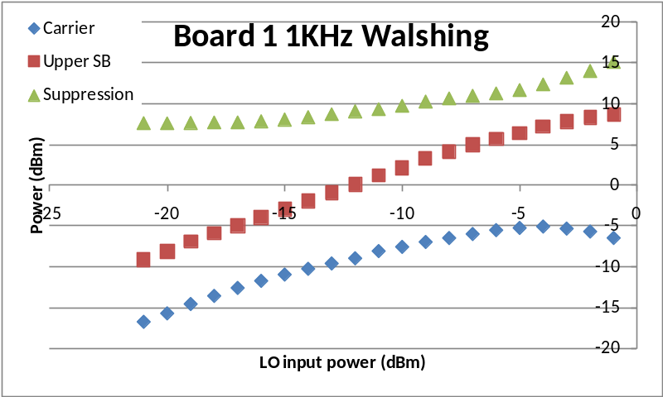
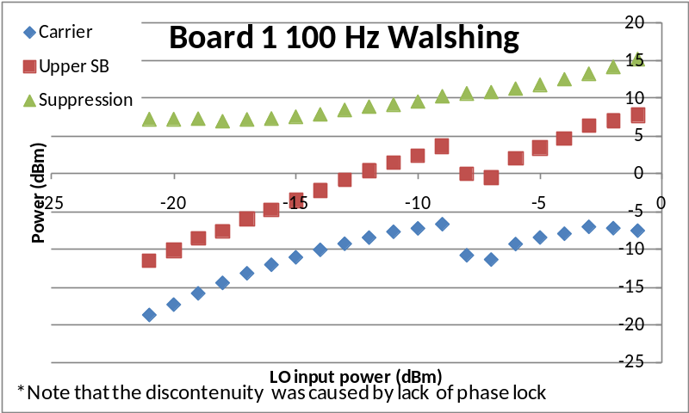

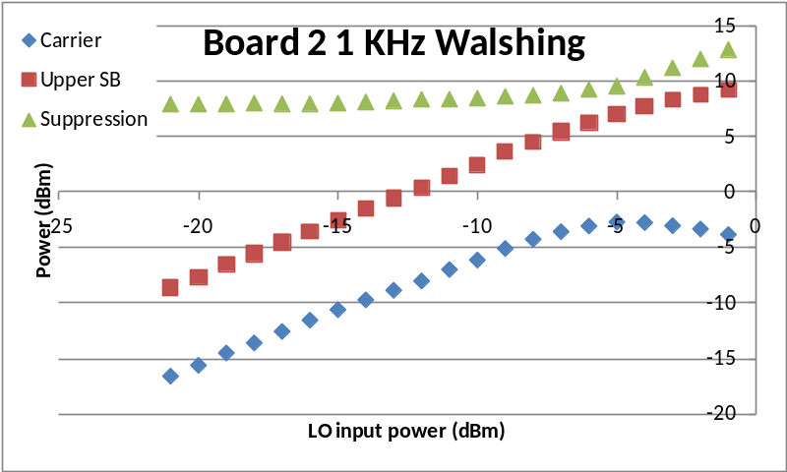
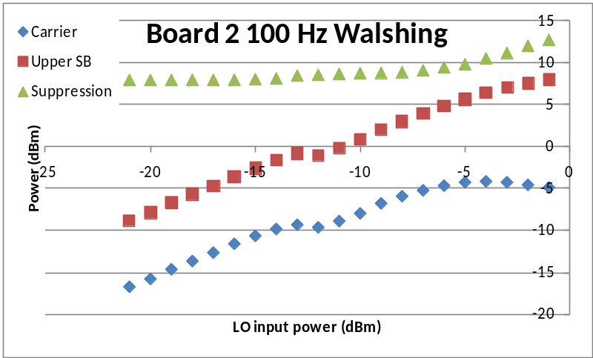
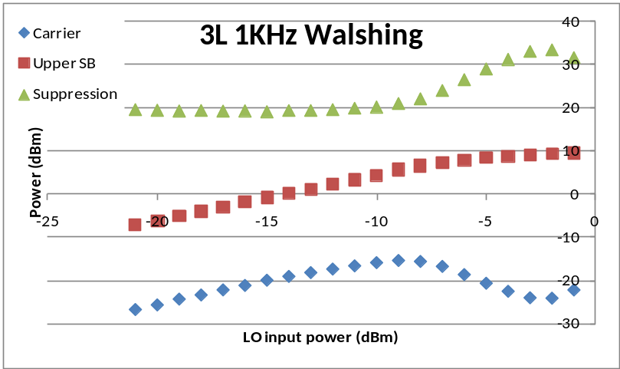
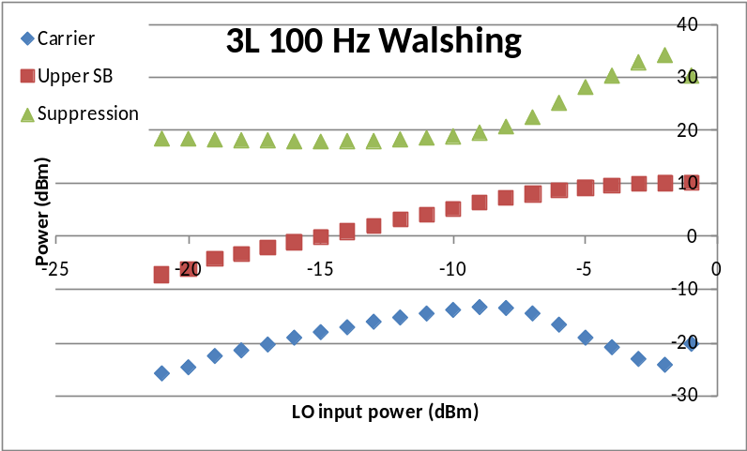

These plots show both the suppression and the individual powers of the carrier and upper sideband for the analysis. It appears that the power of the Upper sideband increased fairly linearly with a small deviation of the line at power above -5 dBm. The Carrier power however shows significant non linearity over the range. Because of the observation that the suppression increases at higher power we decided to look at the relationship between LO power and residual for the RFCBs.

RFCB LO2 power Observations:
The LO input power levels for all the RFCBs were measured to see if there was a correlation between the power level and the degree of Walsh residuals as was seen in the lab tests. Based upon the results as seen below there appears to be little if any correlation between LO2 power and residuals.
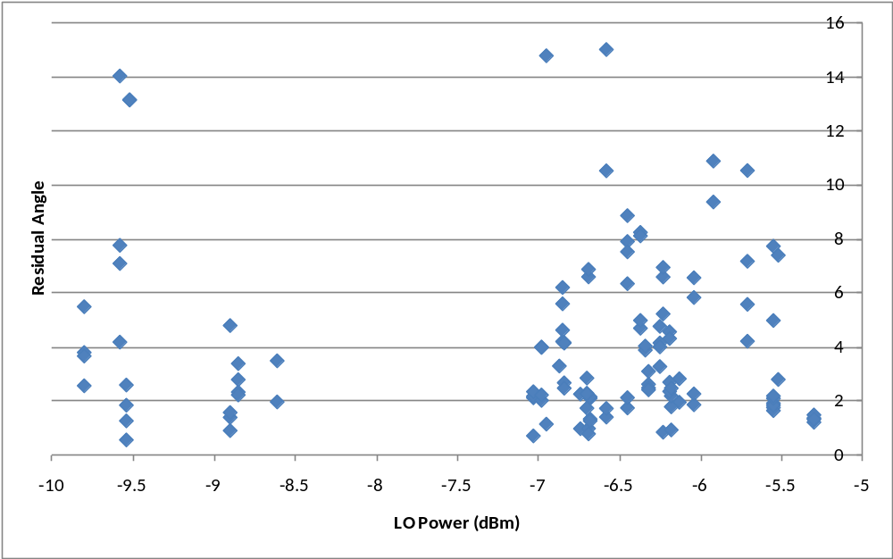
One additional test was made on the RFCB LO2 powers, 3 dB attenuators were added to the LO2 inputs for 3 antennas, one which had large residuals in the first analysis and 2 that had small residuals:
 | No Attenuation |  |  | Attenuated
Antenna | Initial  Power | X-Pol | Y-Pol | Attenuated Power | X-Pol | Y-Pol
2F | -9.56 | 14.14 | 7.81 | -8.50 | 18.2 | 11.47
3G | -6.65 | 1.81 | 2.29 | -9.35 | 2.75 | 3.31
4K | -5.54 | 1.75 | 1.88 | -12.6 | 1.15 | 1.34

Without further data, it is hard to draw any conclusion from this data, however it does appear that decreasing LO power has an effect on the residuals.

